1. **How to check if git is available on your system?**

Answer:=> You can check whether Git is installed and what version you are using by opening up a terminal window in Linux or Mac, or a command prompt window in Windows, and typing the following command: **git –version**



1. **How to initialize a new Git repository?**

Answer :=>

Step 1: Open github and client on new.

Step 2: 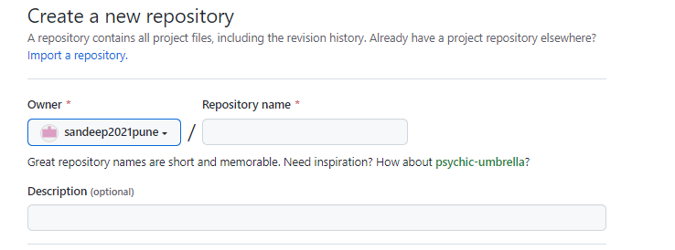

Step 3:

Click on create repository at bottom of the page.

Step 4:

Use the init command to initialize the local directory as a Git repository. By default, the initial branch is called main.

$git init

Step 5:

Add the files in your new local repository. This stages them for the first commit.

$git add

Step 6: Commit the files that you've staged in your local repository.

$ git commit -m "First commit"

Step 7: Push the changes in your local repository to GitHub.com.

$ git push origin main

1. **How to tell git about your name and email**?

Answer: use git config command.





I check if changes are made or not by using below command.

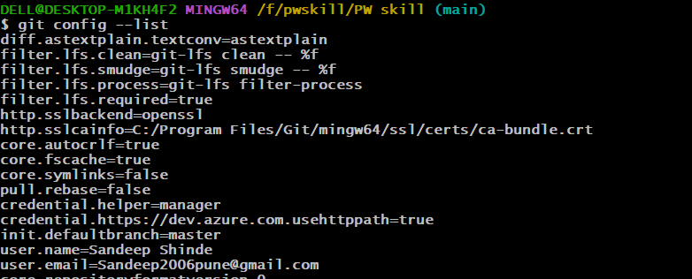

1. How to add the file to staging area?

Answer: We can add fine in staging area by using git add command.



1. How to remove a file from staging Area?

Answer: git rm <file> --cached



1. **How to make commit?**

Answer: git commit -m "commit message"

1. **How to send your changes to a remote repository?**

Answer: To push the commit from the local repo to your remote repositories, run git push -u remote-name branch-name

1. **Whats is difference between clone and pull?**

Answer:

**Clone:** The clone command in git is used when you want to download an existing git repository to your local computer.

**Pull :** When you want to take changes or updates done by other developer/team member on git repository, you have to use git pull.